**VISITOR MANAGEMENT SYSTEM**

**Project Report**

# 

# CONTENTS

| SR NO | CHAPTER NAME | PAGE NO. |
| --- | --- | --- |
| 01 | Objective | 2 |
| 02 | Development Tools | 2 |
| 03 | System Requirements | 3 |
| 04 | Features | 4 |
| 05 | Simulation Instructions | 5 |
| 06 | UML Diagrams | 6-13 |
| 07 | Snapshots | 14-32 |
| 08 | Source Code | 33 |
| 09 | Dev Setup | 33-34 |

# 

# OBJECTIVE

The main objective of this project is to design a dynamic and responsive application for a Visitor Management System with full fledged logic and environment using Java Netbeans and Java Applet with maximum functionalities and efficiency.  
We must ensure that there are two ways of logging into the system depending on the user’s level of access. That is, the visitor and the administrator.

# DEVELOPMENT TOOLS

1. Java GUI Frameworks such as Swing & AWT API.
2. Abstract Window Toolkit
3. Java Applet
4. Webcam API.
5. Java Collections Framework
6. Extra Libraries: Added in dist folder of the Mini-Project Zip File(VMS.zip) and contains jar files used for Print functionality, Mail Functionality and Webcam Capture,Saving PDF version of Pass Details along with Date Picker.

# SYSTEM REQUIREMENTS

1. Operating System: Any
2. jdk latest version
3. Java Netbeans(Use the Import Project Option)
4. Functioning Webcam
5. Proper internet connection
6. Gmail account(For both Host and Visitor).
7. Available Printer for printing VisitorPass1.pdf file which contains the Pass Details(Issued ID Number, Registered Date,Check-In Date,Expected CheckOut Date, Visitor image captured by webcam and name,email,ID Type and ID number of visitor,,Contact number of Visitor alongwith Name and Email of Host).

# 

# 

# 

# FEATURES

1. Webcam Capture API(Implemented through jar files added in Libraries Section of the Project)
2. Mailing Functionality using the 'JavaMail' class which uses the jar files named activation.jar, javax.mail.jar.
3. Printing Functionality(Implemented through jar files added in Libraries of the Project)
4. jcalendar-1.4.jar file for Calendar Dates functionality implemented in Visitor Panel for Check-In Date and Check-Out Date(text fields) since Java GUI Frameworks such as Swing & AWT API does not support Datepicker implicitly.
5. Registration of User(Visitor) and updation of Visitor Details.
6. Login Feature for Admin and Adding Visitors functionality as well as viewing Visitors List functionality for Admin.
7. The Pass Details will automatically be sent to the Visitor & the Host on the provided Gmail.

SIMULATION INSTRUCTIONS

* Run the application(Mini-Project) on Netbeans.

1. Select the User( Administrator or Visitor )
2. For Administrator:
   1. Enter your username and password  
      ( Username: admin , Password: admin123 )
   2. Add Visitor
      1. Enter Visitor Application Form
      2. Submit Visitor Application Form
      3. Print Visitor Pass  
         (If the user does not have a printer connected, then he/she can download a pdf of the visitor pass on the system and can print it later)
   3. Go to Visitor Details
3. For Visitor:
   1. Enter Visitor Application Form
   2. Submit Visitor Application Form
   3. Print Visitor Pass  
      (If the user does not have a printer connected, then he/she can download a pdf of the visitor pass on the system and can print it later)

# 

# UML DIAGRAMS

1. **BLOCK DIAGRAMS**
   1. Administrator Block Diagram  
      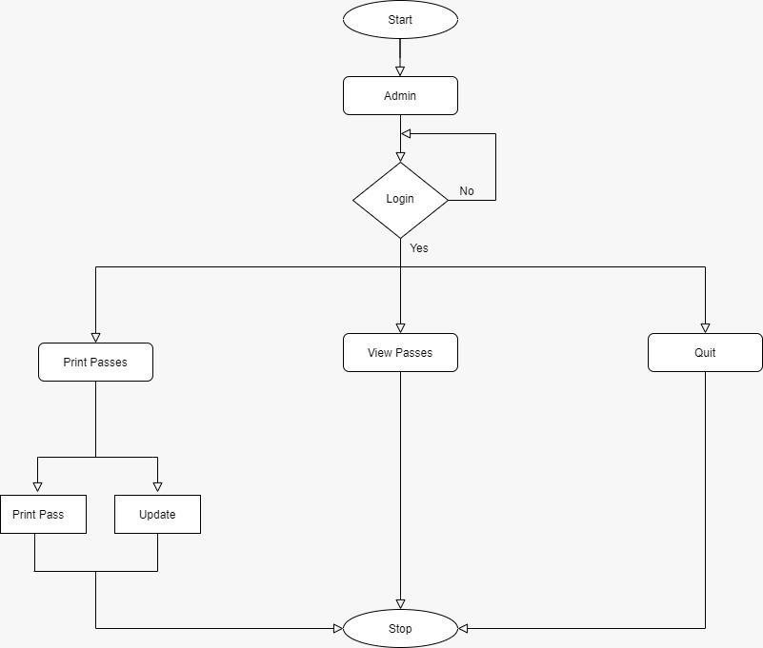

* 1. Visitor Block Diagram  
     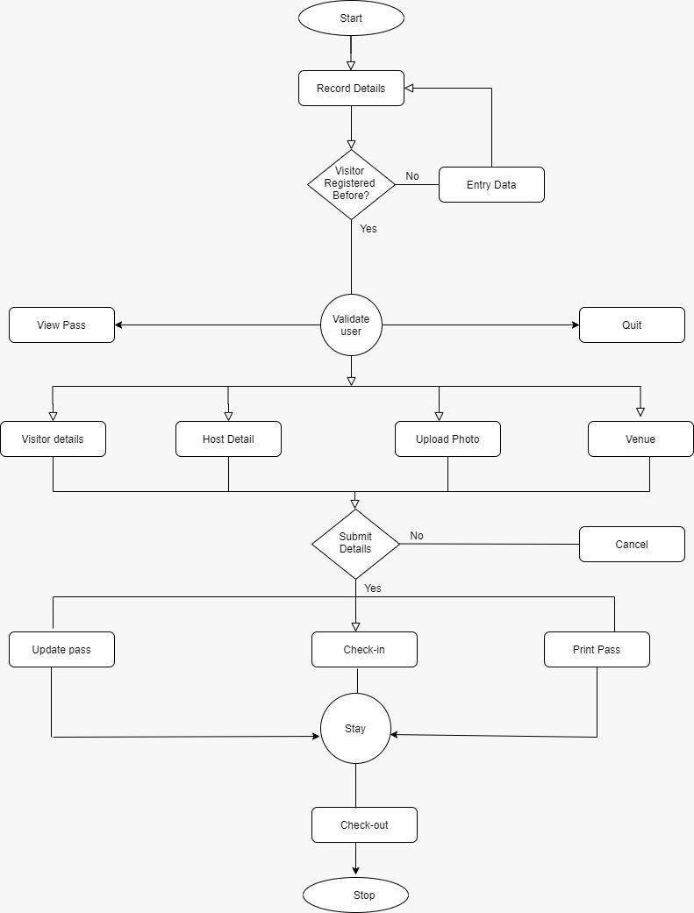
  2. Combined Block Diagram(Administrator and Visitor)  
     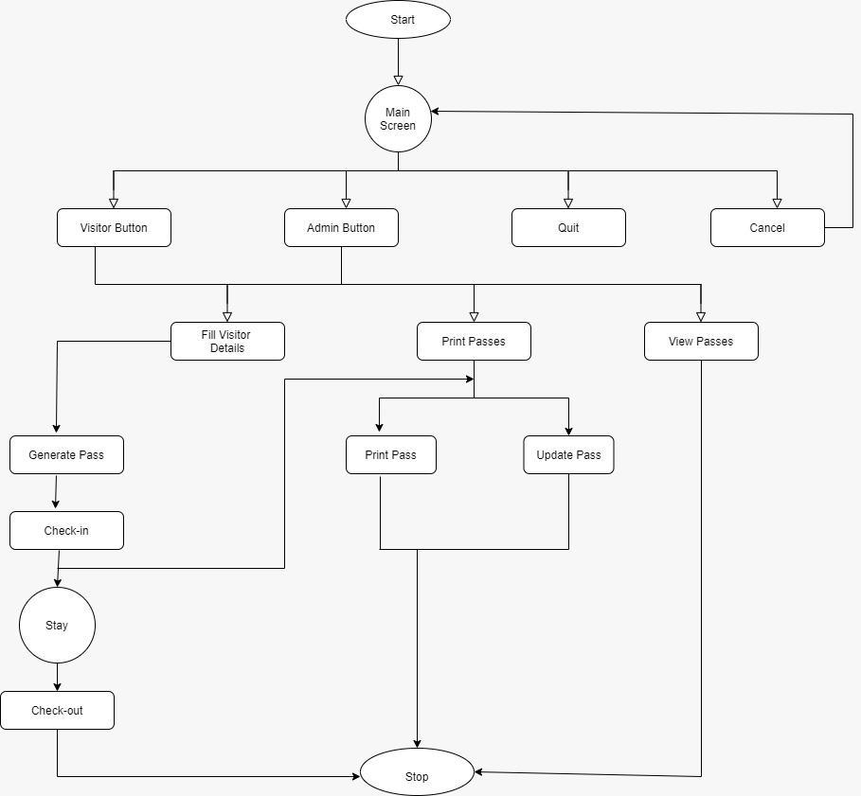

1. **UML CLASS DIAGRAM**  
   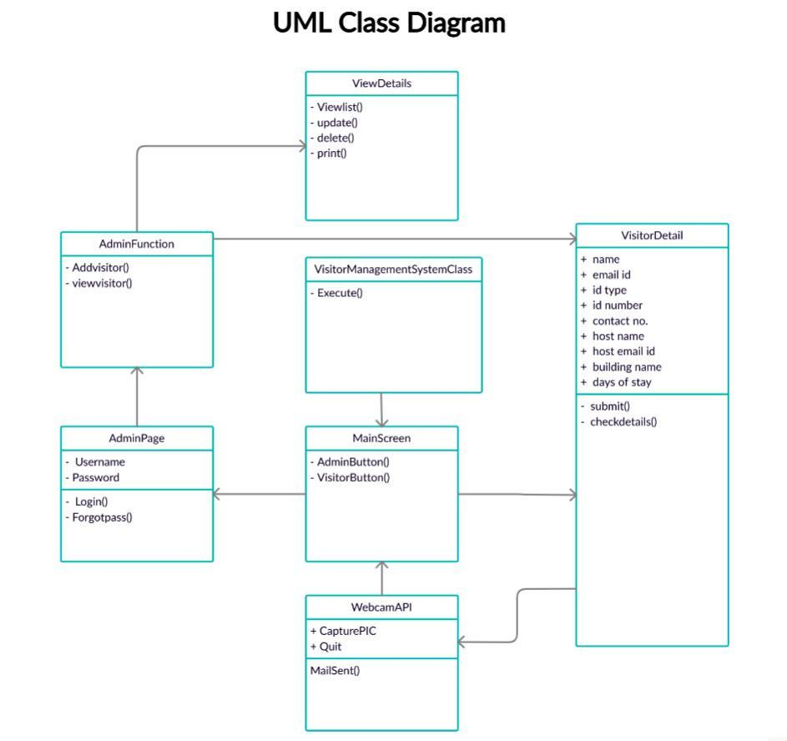
2. **STATE TRANSITION DIAGRAM**  
   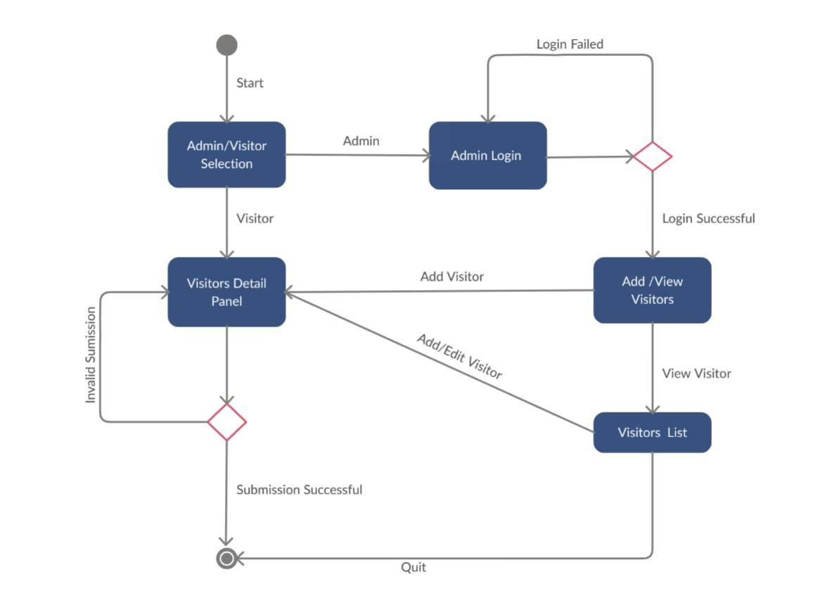
3. **CRC DIAGRAM**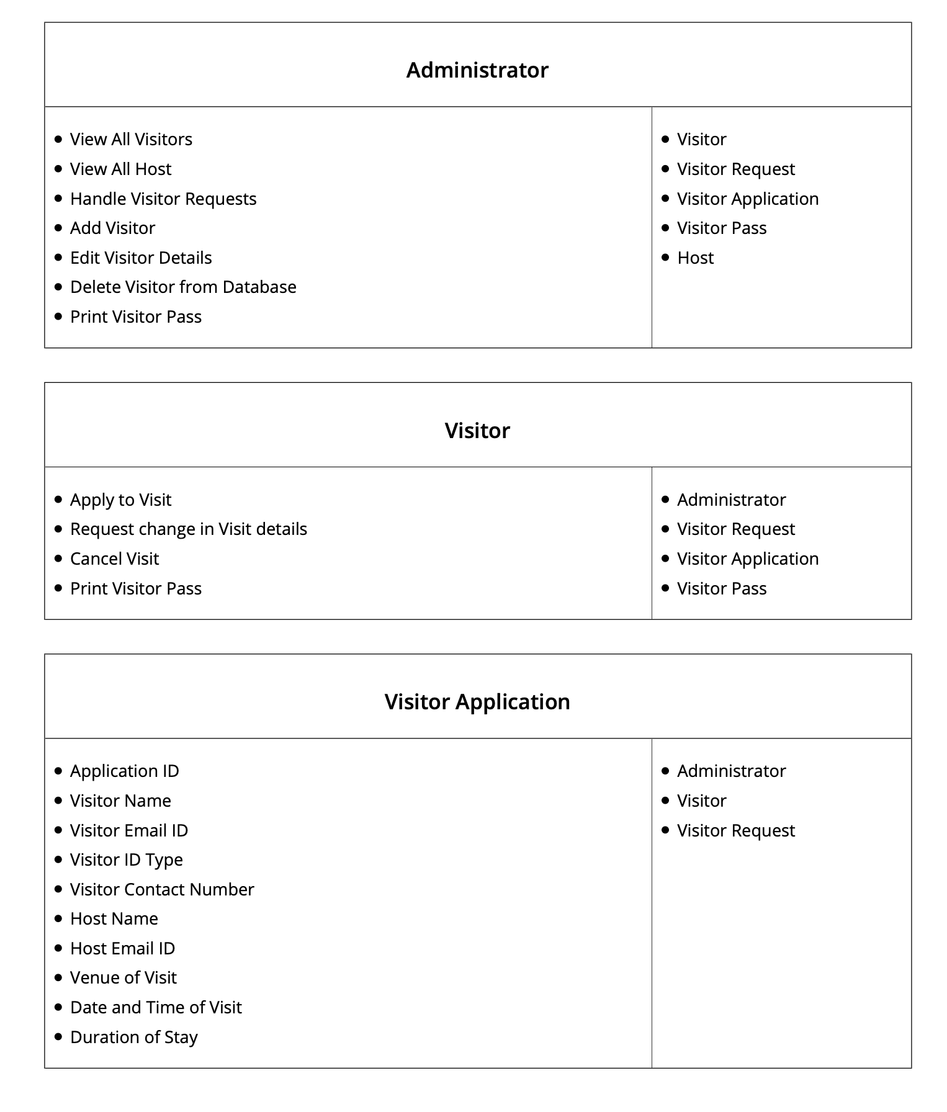  
   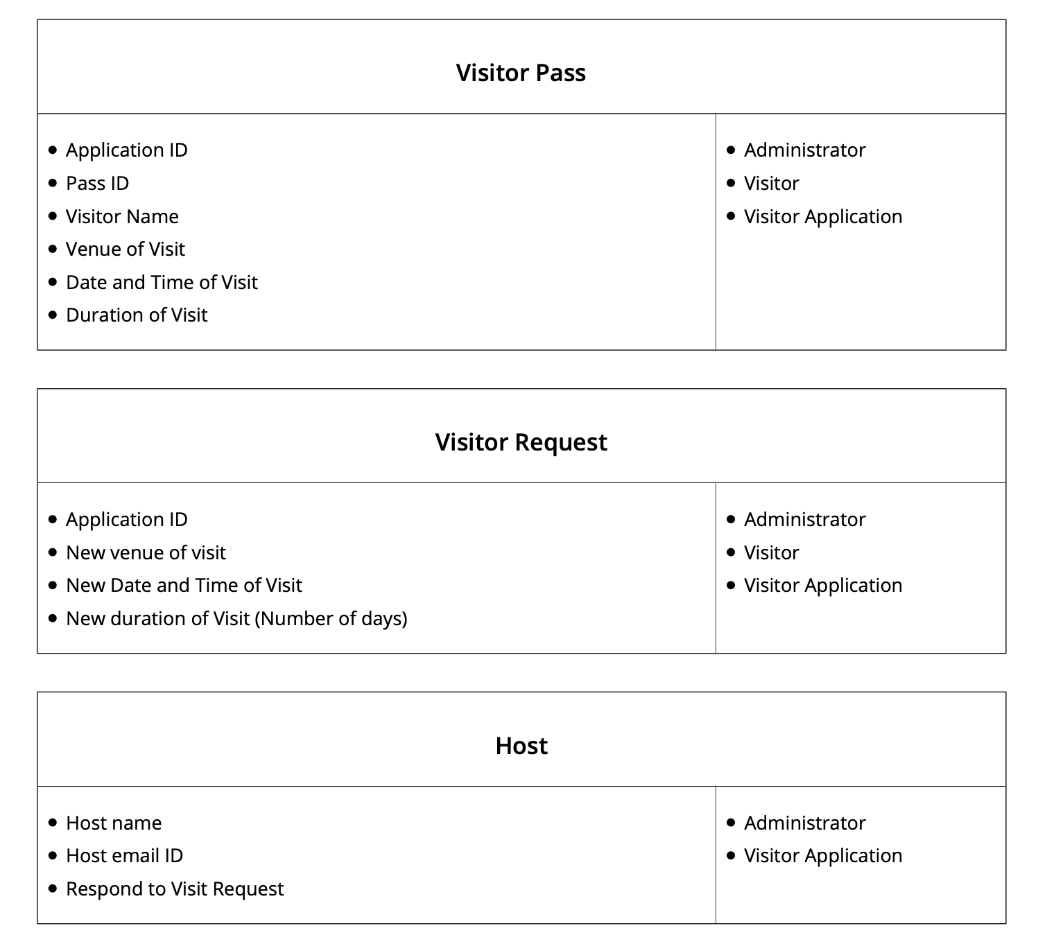

1. **USE CASE DIAGRAM**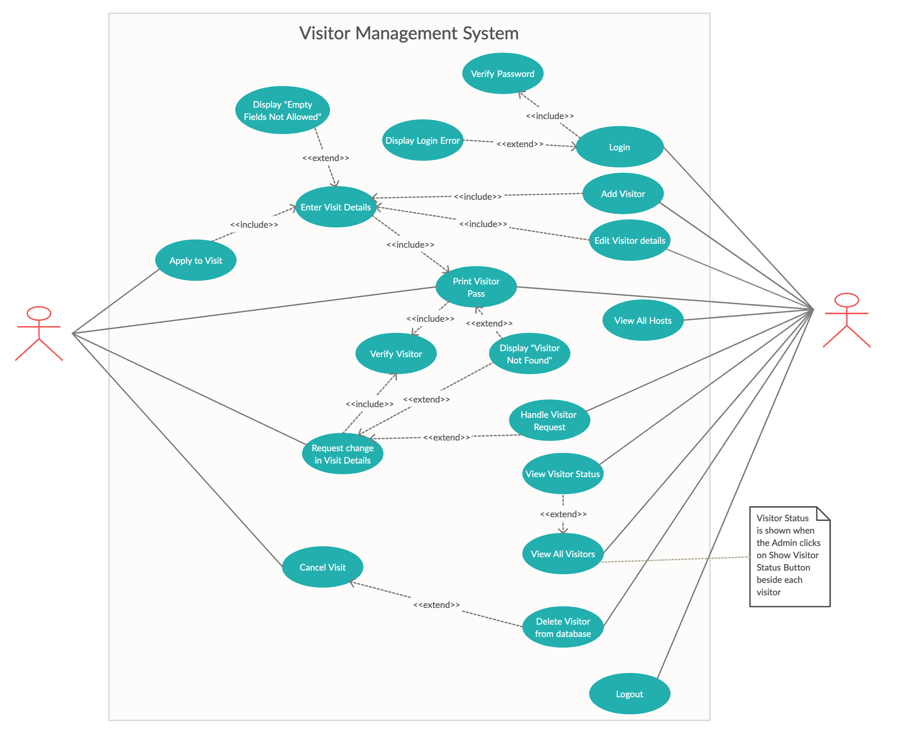

# 

# 

# 

# SNAPSHOTS

1. **Main Screen**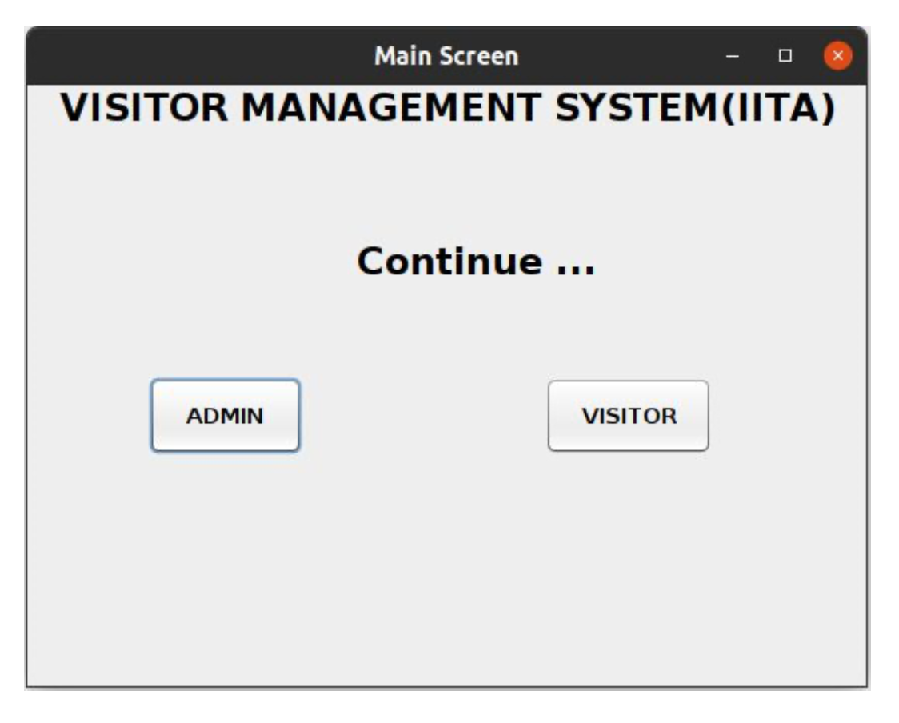

* 1. **Main Screen -> Visitor**  
     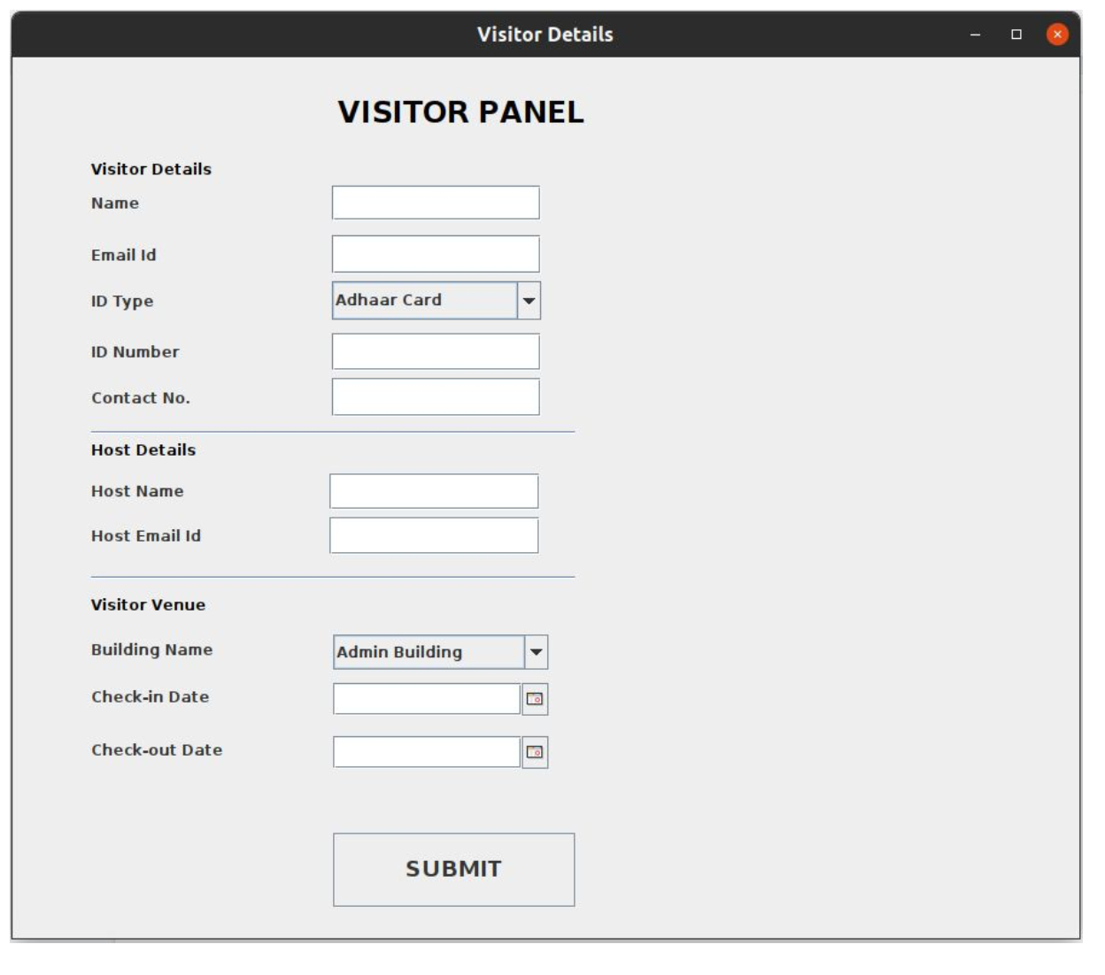
  2. **Main Screen -> Administrator**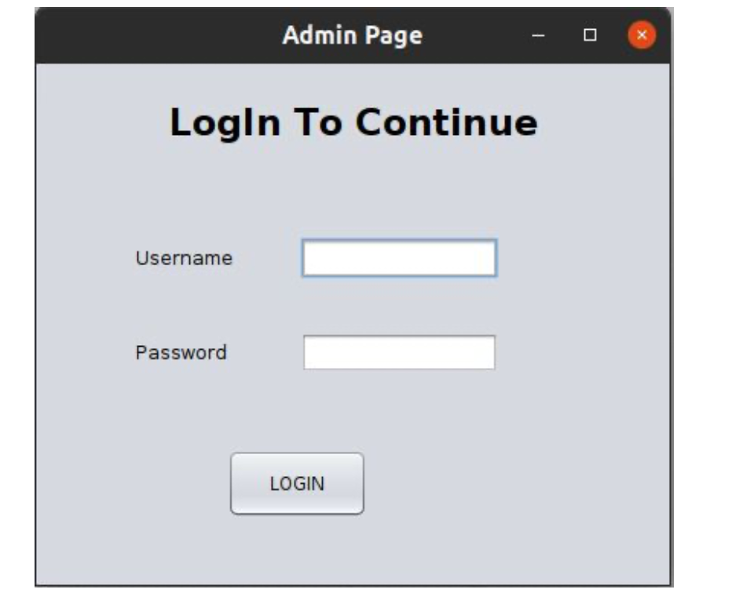  
       
       
       
       
       
       
       
       
       
       
     **Error** message is displayed if any field is left empty while trying to log in.  
     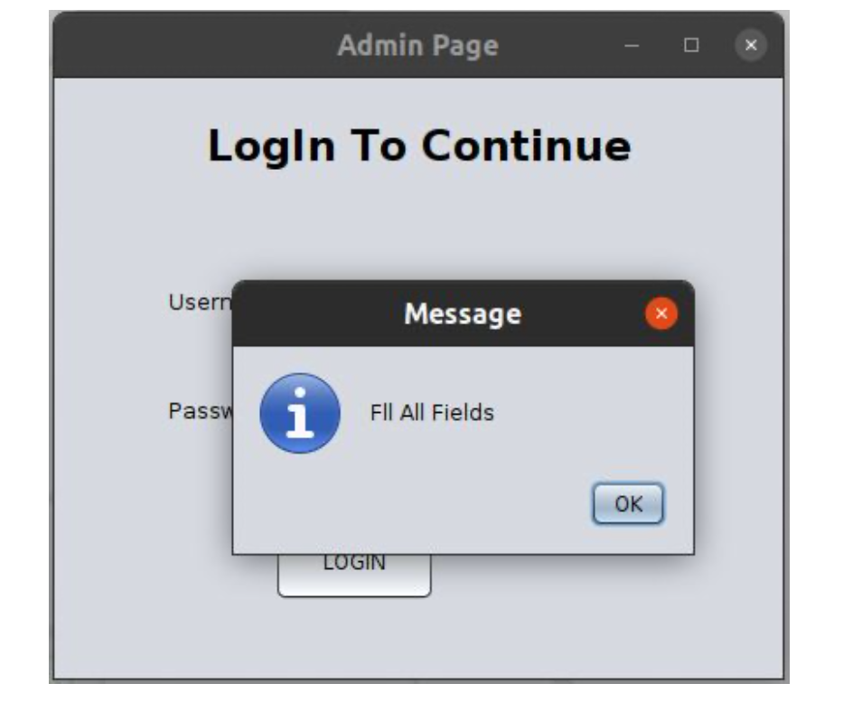

**Error** message is displayed saying “Credentials not matched” if the username or password entered is incorrect.  
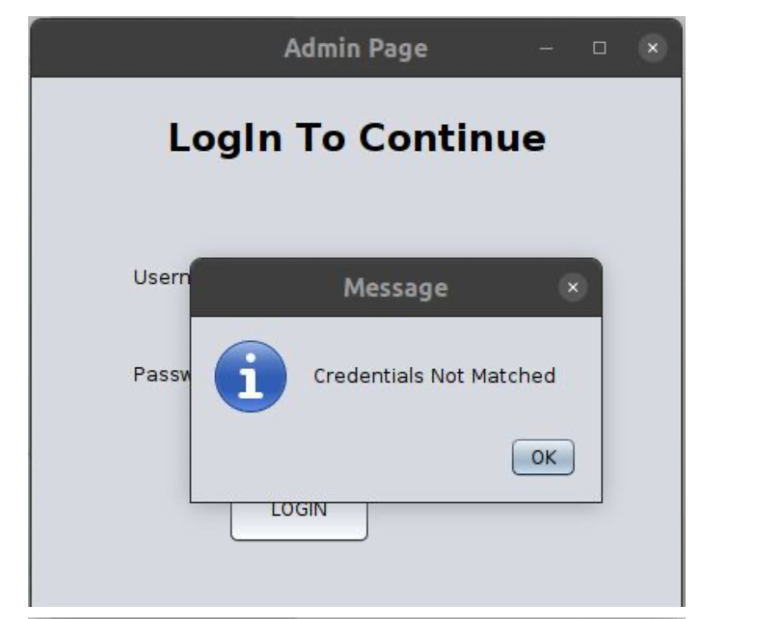

Once the user enters the correct username and password, a JOptionPane dialog box appears saying “Login Successful”.  
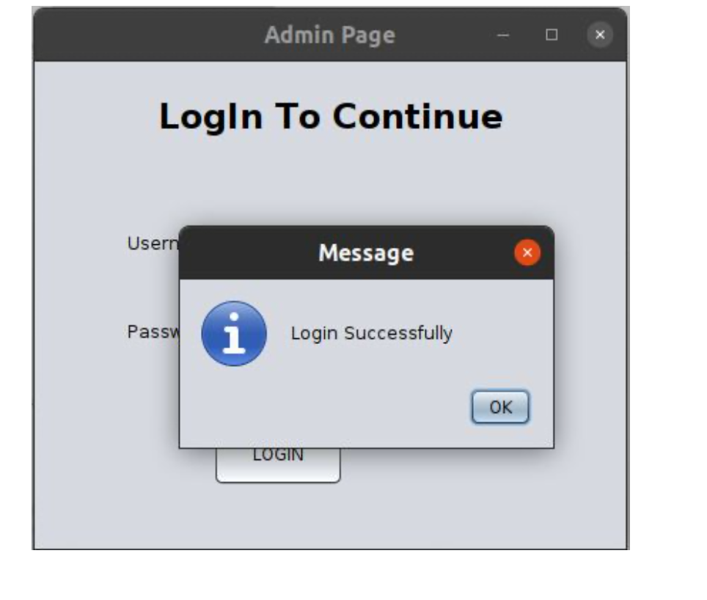

The Administrator Page appears showing two options of Adding a Visitor or Viewing Existing Visitors.  
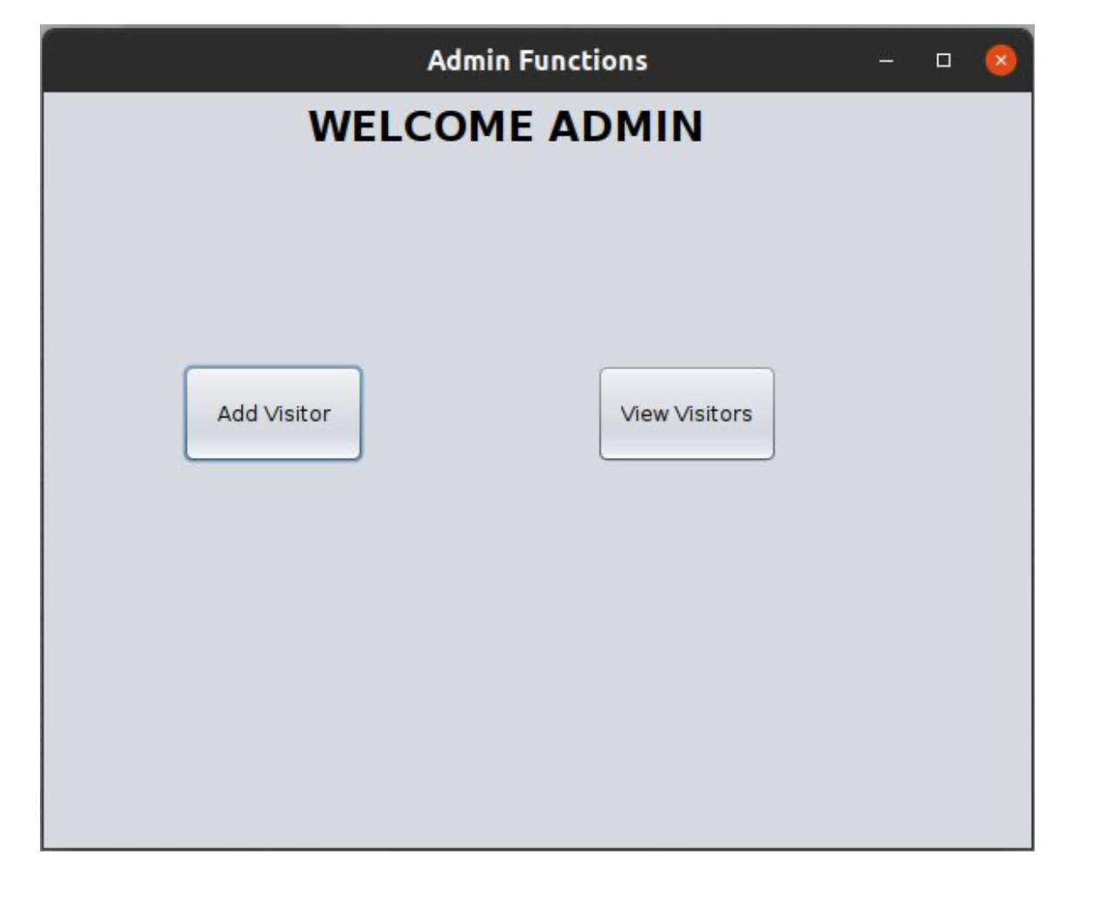

* + 1. **Add Visitor Functionality**  
       **Step 1)** Fill the Visitor Application Form.  
       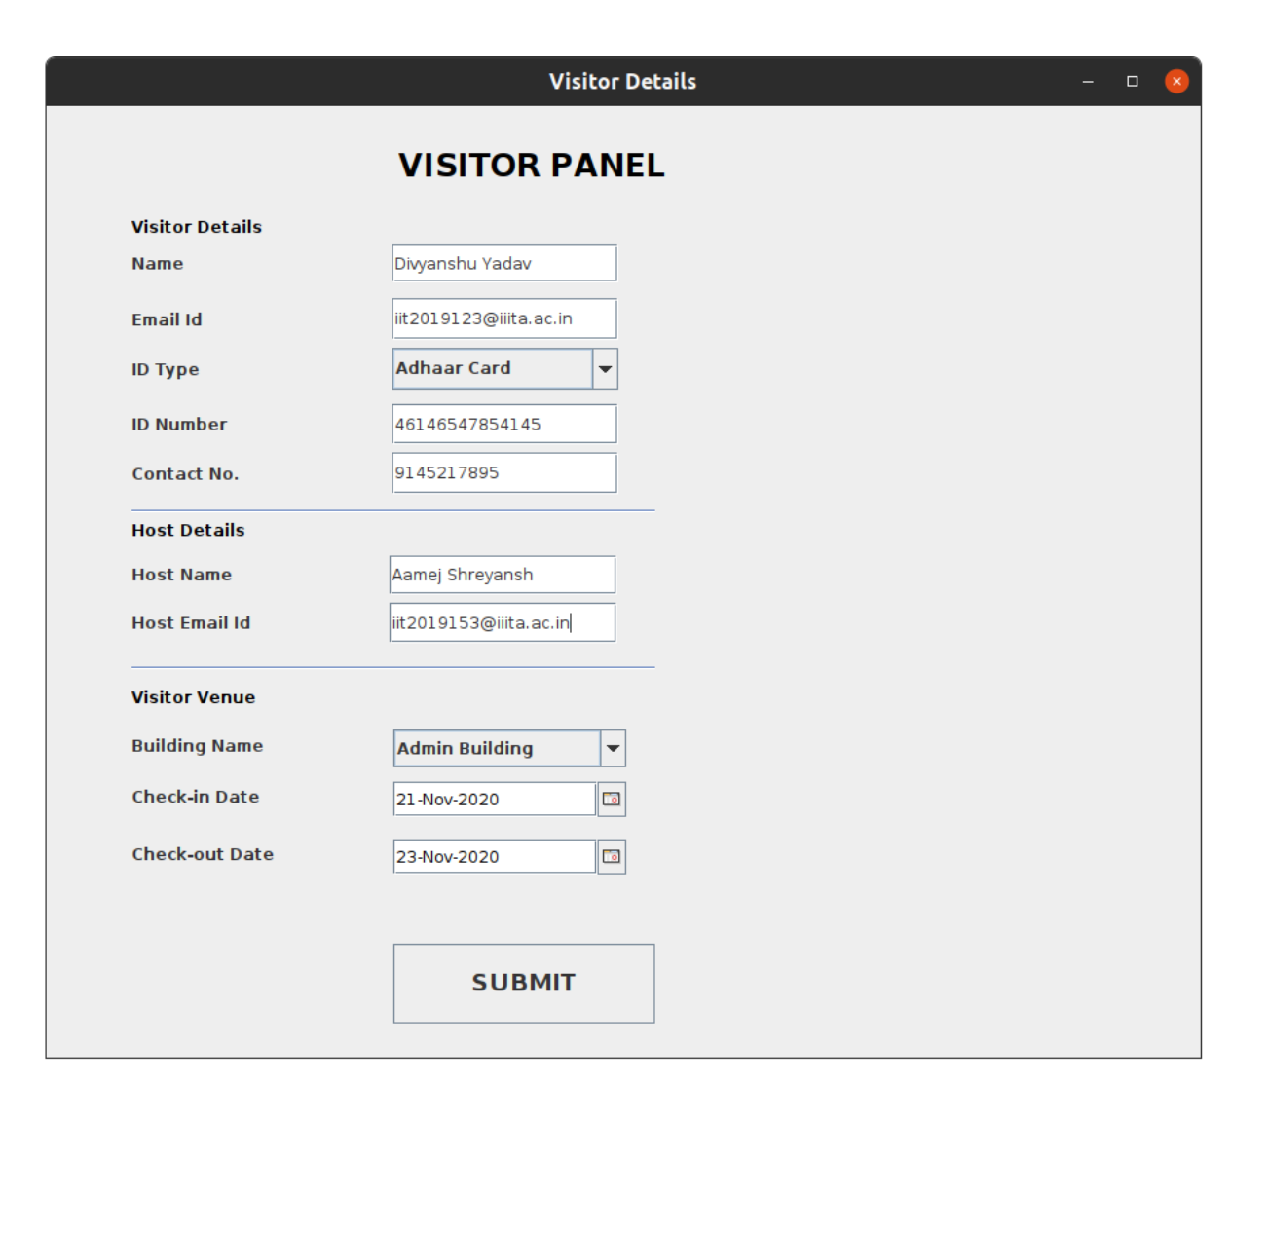  
         
         
         
         
         
         
         
         
         
       **Step 2)** The Visitor will be asked to take an image of himself/herself using the webcam on their system for the Visitor Pass.  
         
       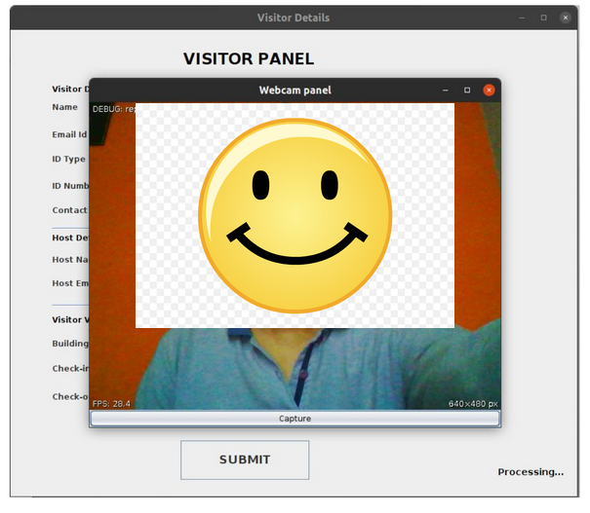  
         
         
         
         
       Visitor Application submitted to the system successfully!  
       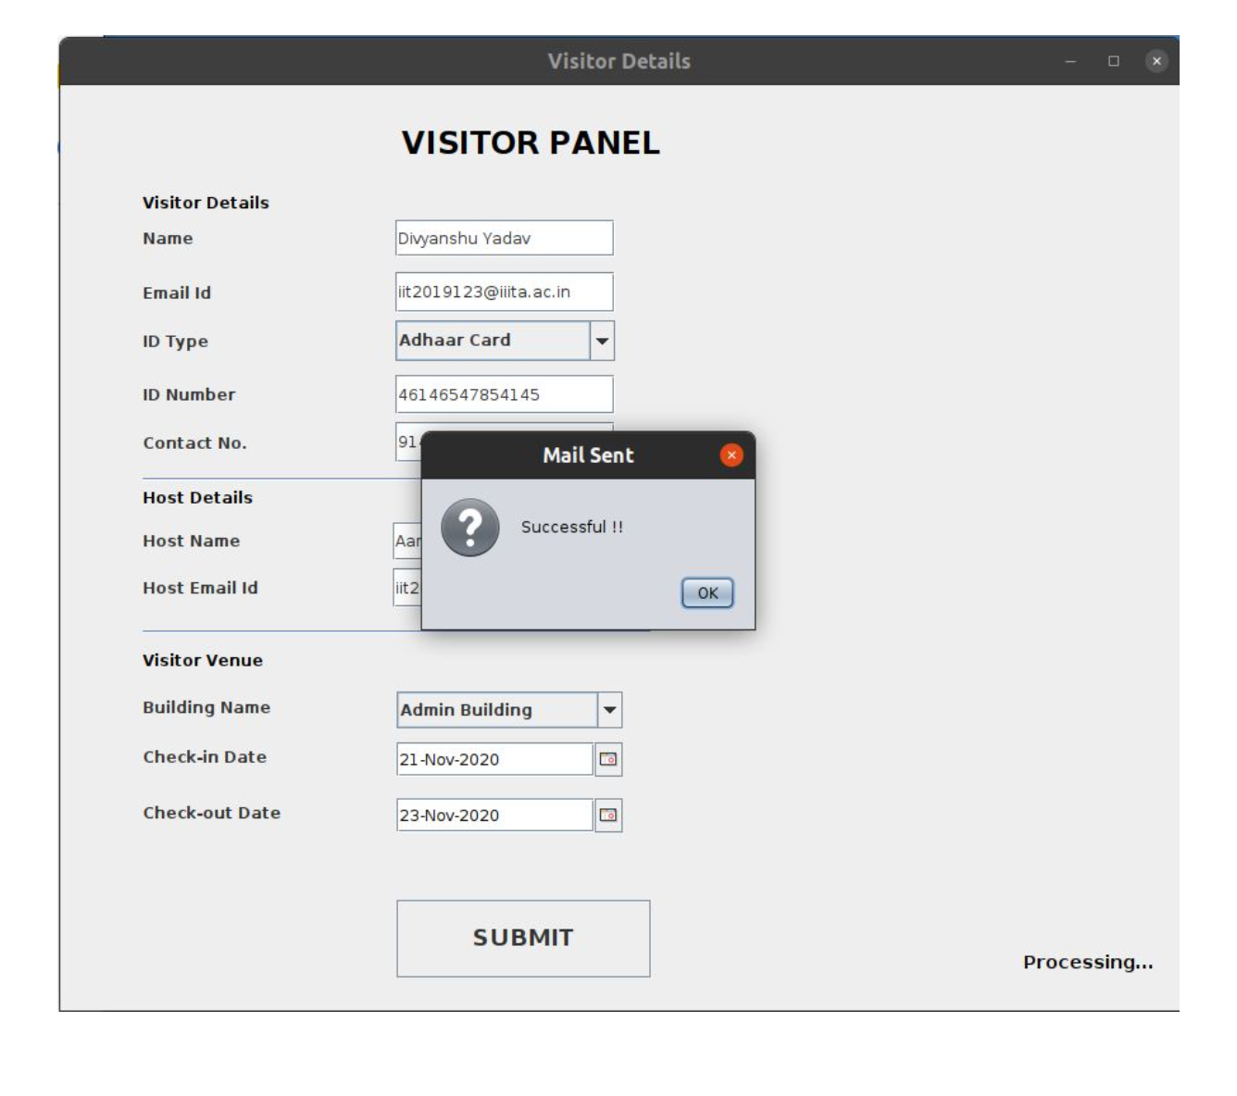

**Step 3)** The user is prompted to either Print the Visitor pass if he/she has a connected printer to the system(Click yes option) or just download the pdf version of the Pass in the system if no printer is available at the moment (Click no option).  
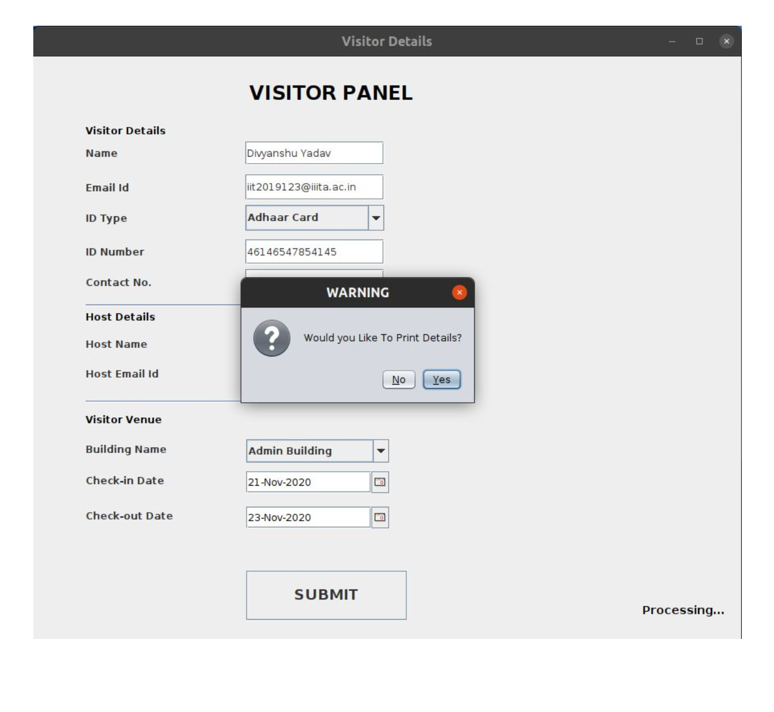  
  
  
  
  
  
**Step 4)** An email is sent automatically by the system to both the Visitor and Host informing them that the particular person has filled the Visitor Application.  
  
**Mail sent to host:**  
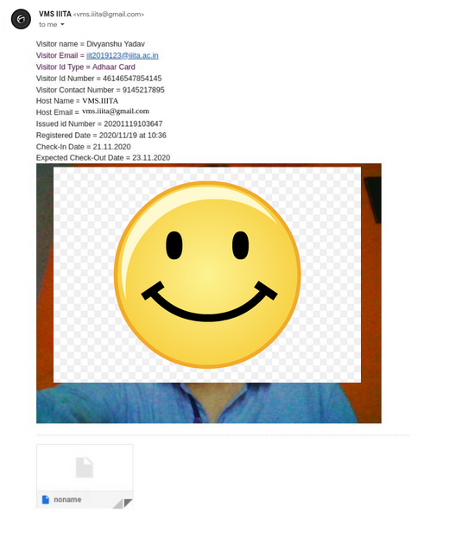

**Mail sent to Visitor:**  
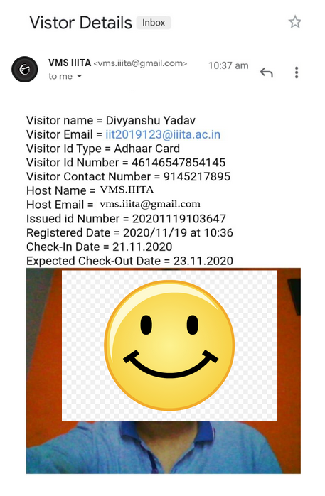  
  
  
  
**The Downloaded pdf version of Visitor Pass:**  
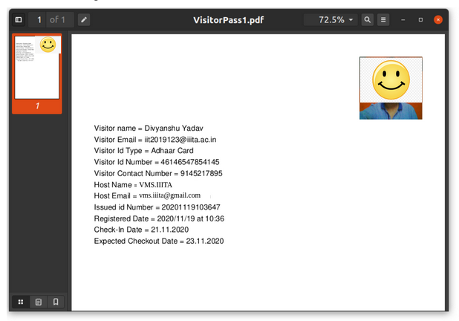  
 **Visitors added into the system!**

* + 1. **View Visitor**Visitor list before any entry is made into the system:  
       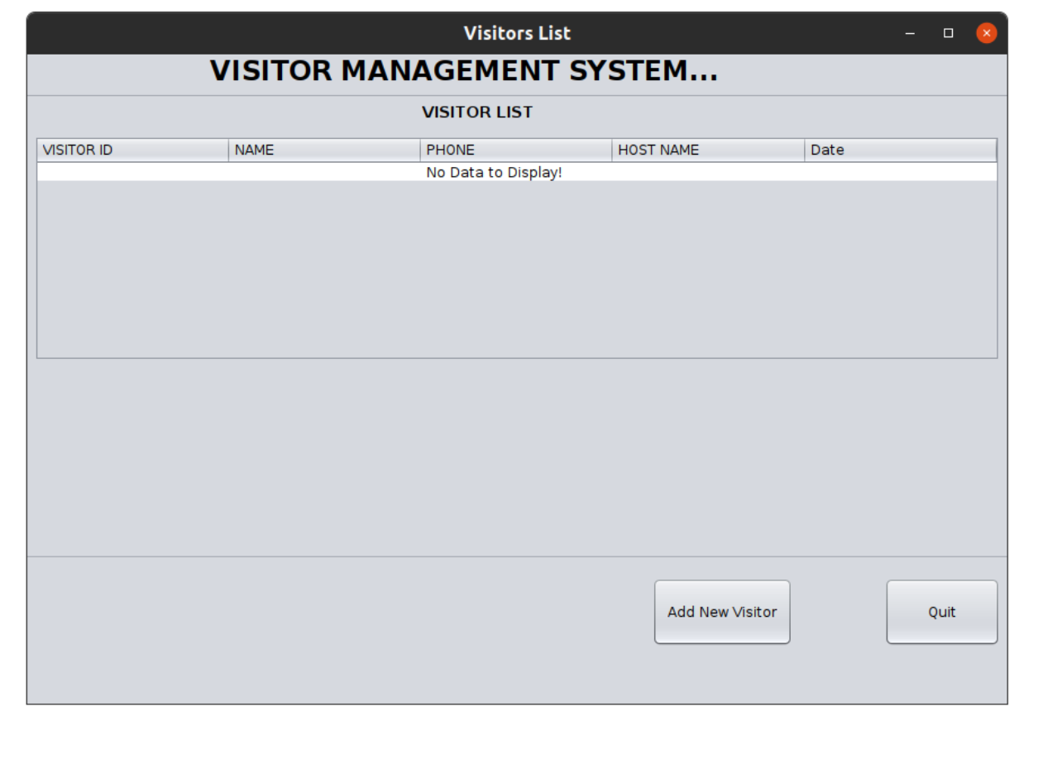

Visitor List after adding an entry into the system:  
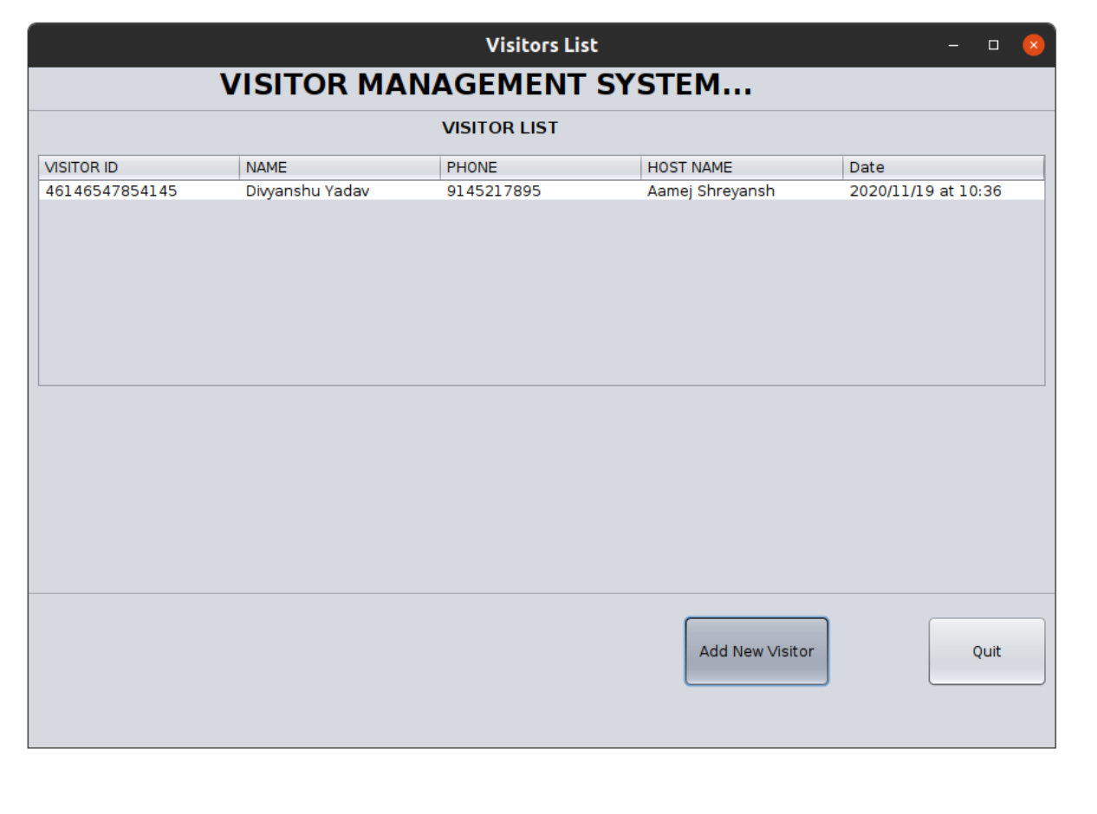

* + 1. **Update Visit details Functionality  
       Step 1)** In order to update the existing Visiting details click on the Add New Visitor button in the Visitor List Panel.  
       

**Step 2)** The Visitor Application Form will open. Fill the application form with the updated details of visit  
(except name and email ID of visitor) and submit.  
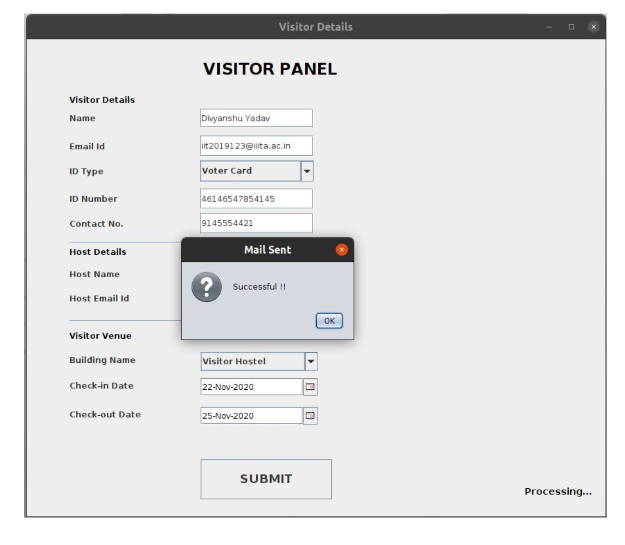  
  
  
  
  
  
  
  
An email(with updated details and issued ID number) is sent to both the visitor and the host informing them that the person has filled the visitor application form with the respective details of the visit.

**Step 3)** The updated Visiting details are added into the system and can be viewed by the administrator in the Visitors List panel as shown below.  
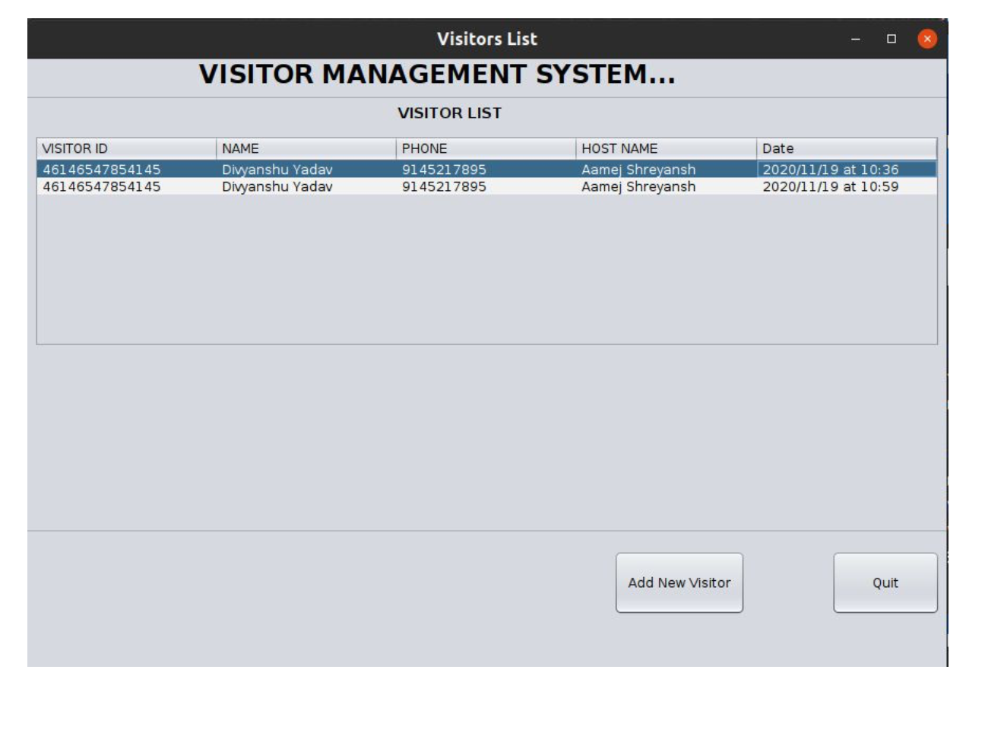  
  
**#Note:** As we have incorporated Collections Framework in this project instead of Database, instead of deleting the older Visit details, we simply add the new updated visit details in the Visitor List as the updated record will only be counted valid, not the older records of the same person.

# SOURCE CODE

Github: https://github.com/Dy-123/VMS

# DEV SETUP

=> Download source code

Update the Paths where Image and VisitorPass will be stored in your operating system.To update the paths edit line number 385,431,629,663 in VisitorDetail.java

In VisitorDetail.java

Change line 59, 60(d_password,d_mail variable) to change mail which will send the visitor their details.

=> Add Required libraries

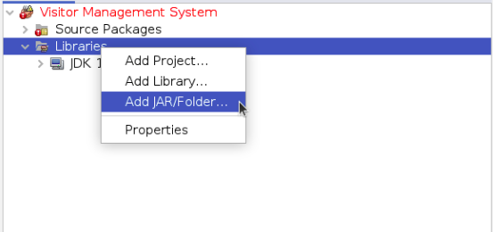

Click on Add JAR/Folder then go inside lib and select all libraries.

After adding libraries your director will look like this

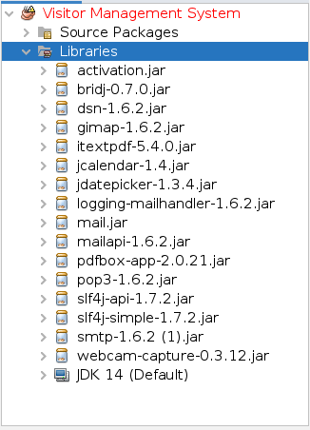

=> To run the project from the command line, go to the dist folder and type the following:

java -jar "Visitor_Management_System.jar"

=> Admin login Credentials

Username : admin

Password : admin123